Access Statement for the Royal Observatory Greenwich

Please note all information contained within this document is accurate 27/12/2023
The Royal Observatory
Commissioned in 1675 by King Charles II and designed by Sir Christopher Wren, The Royal Observatory is a set of historic buildings that played a major role in the history of Astronomy and Navigation. It is home to the Prime Meridian Line and the Harrison clocks, both vital for the and use of Longitude for navigation at sea.
Planning your visit
The Royal Observatory is located at the end of Black Heath Avenue inside Greenwich Park at the top of Prime Meridian Walk hill. In the next section, “Getting to Greenwich Park”, each option will highlight if the entry point requires you to climb a hill to get to the Observatory. For routes including a hill, there are two options.
Prime Meridian Walk
Directly north of the Observatory, Prime Meridian Walk is the most direct route to the observatory, when walking through the park from Greenwich. The hill itself is on average 5 minutes but with a steep 90ft incline. At the top of the hill there are eight unavoidable steps.
The Avenue (St Marys Gate Entrance)
Alternatively, The Avenue is the main road running from the main entrance of the park (St Mary’s Gate) and connects to Blackheath Avenue and the Observatory. This route is longer, walking uphill for an average of 13 minutes. However, there is a gentler incline than on Prime Meridian Walk. There are also no unavoidable steps on this route to the observatory.
During the summer months Greenwich Park operates a free mobility buggy service between St Mary’s Gate and the Pavilion café. Please note that this service is run by volunteers and therefore subject to potential last minute changes.
Getting to Greenwich Park
Greenwich Park is well-served by bus routes and is within 20 minutes walking distance of Blackheath, Greenwich and Maze Hill railway stations.
Overground Trains
Nearest stations:
Greenwich: Thameslink and Southeastern Trains. Walking from this station takes 20 minutes and does not avoid hills.
For further information about Greenwich station please visit
https://www.nationalrail.co.uk/stations/greenwich/
Maze Hill: Thameslink and Southeastern Trains. Walking from this station takes 15 minutes and does not avoid hills.
For further information about Maze Hill station please visit
https://www.nationalrail.co.uk/stations/maze-hill/
Blackheath: Thameslink and Southeastern Trains. Walking from this station takes 20 minutes and does not require using either hill in Greenwich Park.
For further information about Blackheath station please visit
https://www.nationalrail.co.uk/stations/blackheath/

Docklands Light Railway (Does not avoid hills)
Cutty Sark station - Cutty Sark station is currently closed until March 2026.
Greenwich station – Walkin from this station takes 20 minutes and does not avoid hills.

Tube
Jubilee Line to North Greenwich, then use the 188 or 129 bus, details below.

Bus (See routes below)
53 Lower Marsh - Plumstead (No Hills) Stops directly outside Blackheath Gate entrance.
54 Woolwich - Elmers End (No Hills) Maze Hill bus stop for Blackheath Gate entrance.
129 Gallions Reach to Lewisham (Does not avoid hills) Stops: National Maritime Museum for St Mary's Gate entrance on King William.
177 Thamesmead – Peckham (Does not avoid hills) Stops: National Maritime Museum for St Mary's Gate entrance on King William Walk.
188 North Greenwich - Russell Square (Does not avoid hills) Stops: National Maritime Museum for St Mary's Gate entrance on King William Walk.
199 Canada Water - Catford (Does not avoid hills) Stops: National Maritime Museum for St Mary's Gate entrance on King William Walk
286 Greenwich - Sidcup (Does not avoid hills) Stops: National Maritime Museum for St Mary's Gate entrance on King William Walk.
202 Crystal Palace - Blackheath (No hills) Maze Hill stop for Blackheath Gate
380 Lewisham - Thamesmead (No hills) Maze Hill stop for Blackheath Gate
386 Greenwich - Woolwich (Can avoid hills) Greenwich Park stops for Blackheath Gate or National Maritime Museum for St Mary's Gate entrance on King William Walk
108 Stratford - Lewisham via North Greenwich (No hills) Royal Parade or Montpelier Road stops for Blackheath Gate

Riverboat
Nearest stop: Greenwich Pier
Boats depart from Westminster Pier, Embankment Pier or Tower Pier. Parking facilities and disabled parking available.
Maps and information on the Uber Boat by Thames Clippers website
By Car
Car parking is available via the Blackheath Gate entrance to the park only. Postcode for satellite navigation device users is SE10 8QY. The car park in Greenwich Park is open seven days a week during park opening hours. The Car Park runs along Blackheath Avenue from the Blackheath Gates entrance down to the Royal Observatory. Walking time for the car park to the Observatory range on average from 2 to 8 minutes. This option avoids hills. Parking is metered and managed by Royal Parks.
Car parking available on the Royal Museums Greenwich website is located at the National Maritime Museum and not the Royal Observatory. Booking Parking at the Maritime Museum does not avoid hills and is on average a 15-to-20-minute walk to the Observatory.

Entrance to the Royal Observatory
There is an entrance fee for the Royal Observatory. For further information regarding tickets offered, opening hours and showtimes please visit www.rmg.co.uk or contact 020 8312 6608.

Additional Resources
There are two Wheelchairs available that can be borrowed*, to book in advance please email bookings at bookings@rmg.co.uk or call them on 020 8312 6608.
*Please note these wheelchairs cannot leave the Royal Observatory for any reason. For example, to go to the National Maritime Museum.
Assistance is not provided with a wheelchair, but a trained member of staff will set it up and explain its features.
A First Aid Room or Changing Room is not available on site, the nearest Changing places facility is at the National Maritime Museum.
Hearing loops are fitted at all ticket desks.
Assistance dogs or accredited therapy/support dogs are welcome on site. We are unable currently to welcome any other animals.

Smartify – Audio Tour
A free audio tour is available through downloading the Smartify app this tour is available in a variety of languages and also has options for subtitles or British Sign Language.
It is recommended to download Smartify in advance and bring your own headphones as we are not able to offer any on site.

Getting around the Royal Observatory
The entrance to the Royal Observatory is via the Time for the Navy Gate located near the Great Equatorial Telescope Building with the onion dome.
Entrance Gate to Royal Observatory is 154 cm wide. The path to the ticketing office is made of concrete tiles.

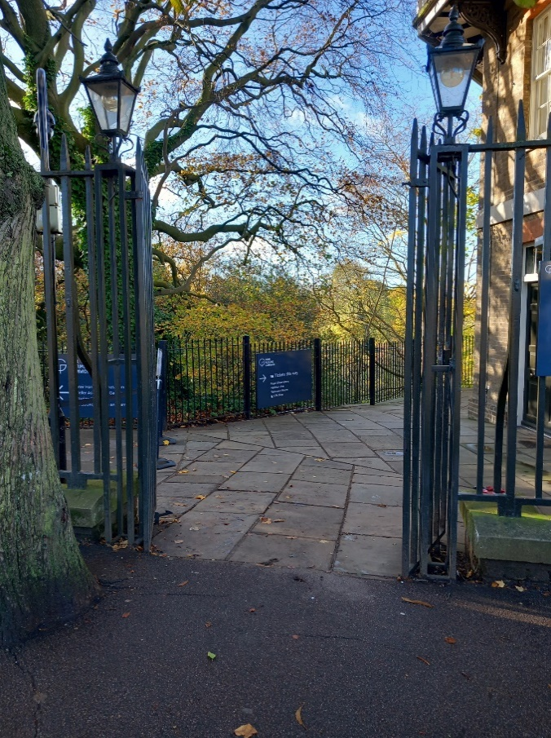
Image 1 Entrance Gate to Royal Observatory

The main ticket office for the Royal Observatory is accessible via a ramp which is 151 cm wide. The ticket office entrance is 98 cm wide and utilises an automatic door. The floor surface is level made of concrete tiles. The desk heights are 105 cm. The exit door is 74 cm wide.

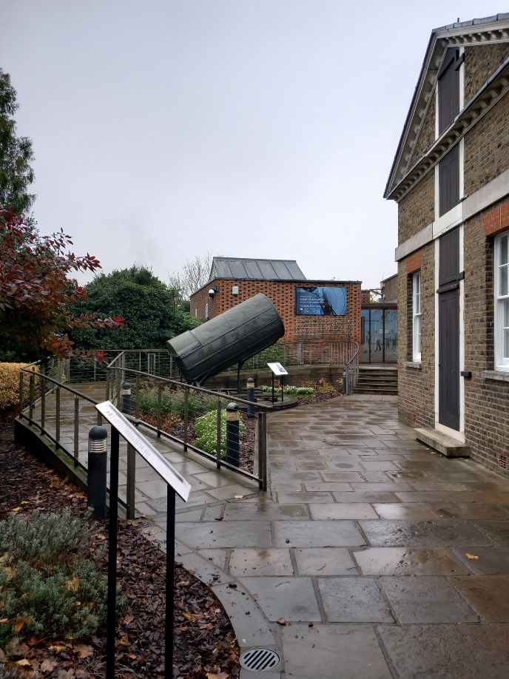
Image 2 Path and ramp to ticket office
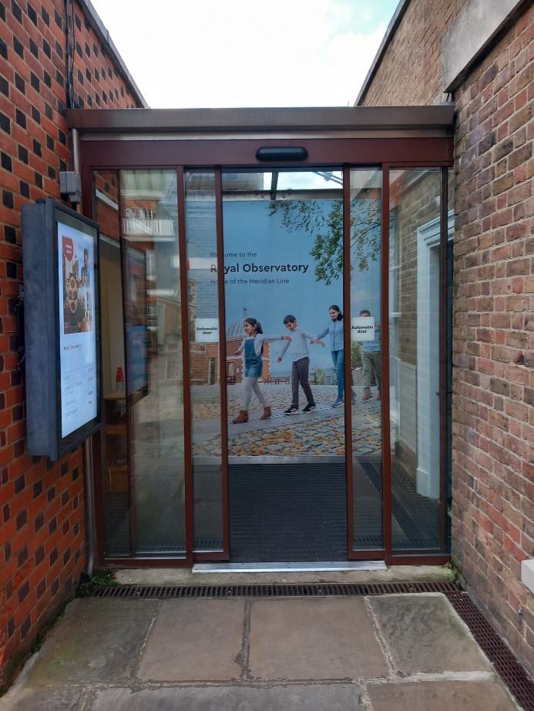
Image 3 Entrance to ticket office

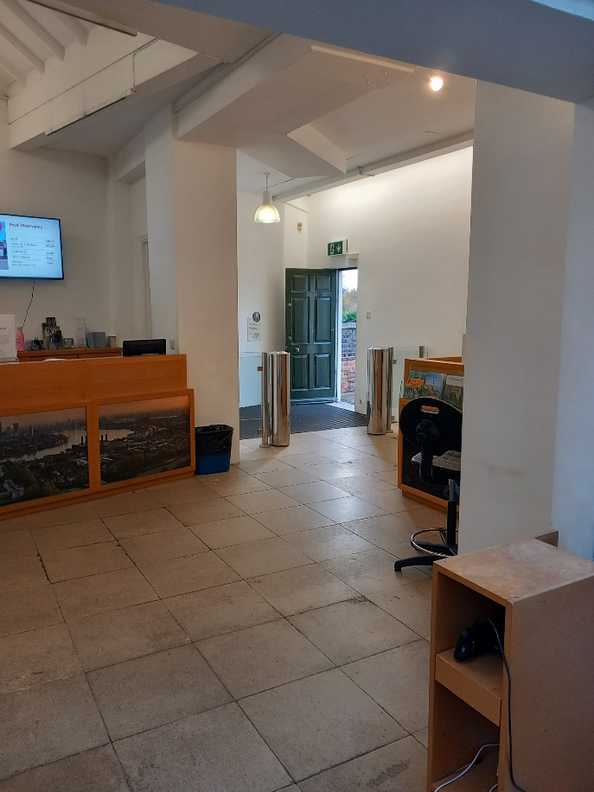
Image 4 Inside ticket office

The cobblestone courtyard can be uneven in areas. This can be difficult for those using a wheelchair, but only needs to be travelled if you wish to see the views from the fence line.

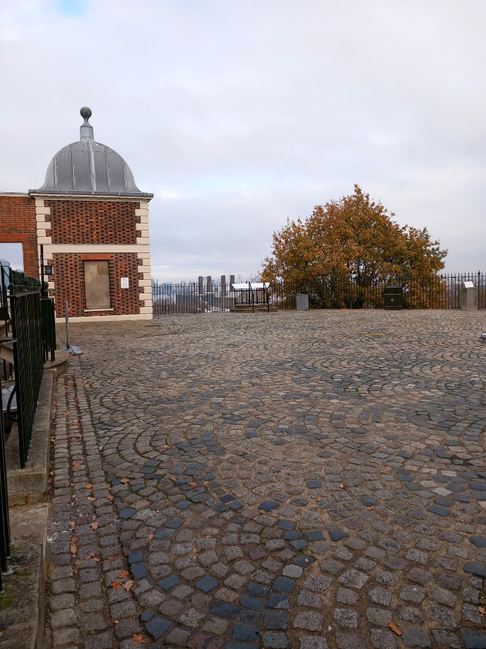
Image 5 Cobblestone Courtyard

Flamsteed House
Please note buggies are not allowed in Flamsteed House due to its narrow galleries, but there is an external Buggy Park provided.
There is limited seating available in Time and Longitude and Time and Greenwich galleries.
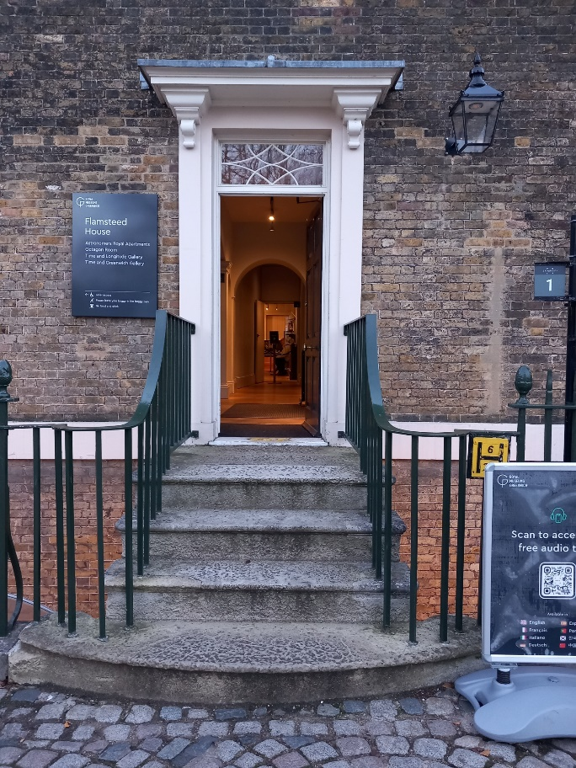
Image 6 Flamsteed House entrance
Four concrete steps lead to the entrance of Flamsteed House. The minimum depths of the steps are 34 cm. The doorway is 88 cm wide. Measurement between the railing on the stairs is 126 cm.
There is wooden flooring throughout Flamsteed House, except for the last gallery Time and Greenwich which has vinyl flooring.
The light levels vary throughout the house due to some more sensitive works of art.
The doorways in the apartments vary in widths between 74 and 94 cm.
The staircase leading up to the Octagon Room has 17 steps and also requires a change in direction whilst climbing. The door to the Octagon Room is 80 cm wide.
The Octagon Room is well lit, with lots of natural lighting coming through the windows.
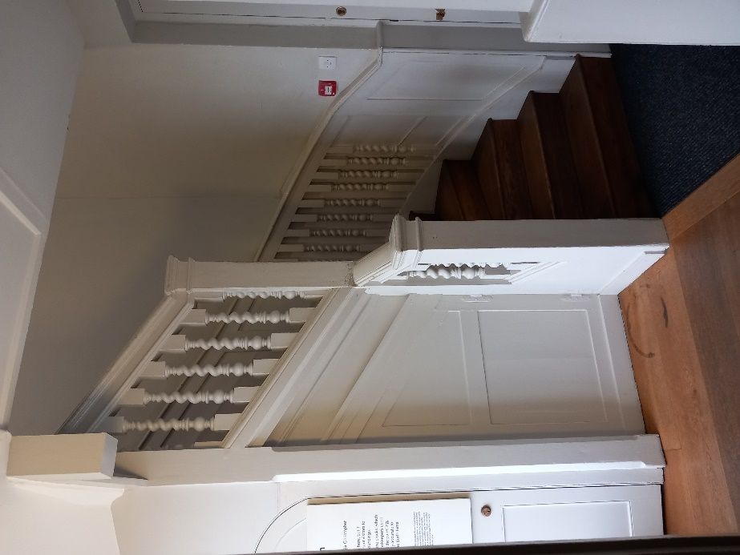
Image 7 Stairs to Octagon Room
The staircase to take you down from the Octagon Room to the Time and Longitude gallery consists of 3 flights of stairs with a total of 17 steps.
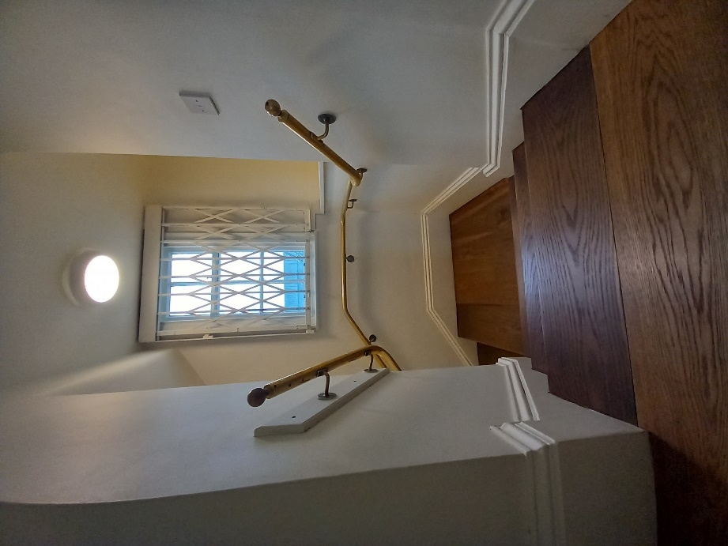
Image 8 Staircase from Octagon Room

There are 3 flights of carpeted stairs with a total of 20 steps leading to the Time and Greenwich gallery.
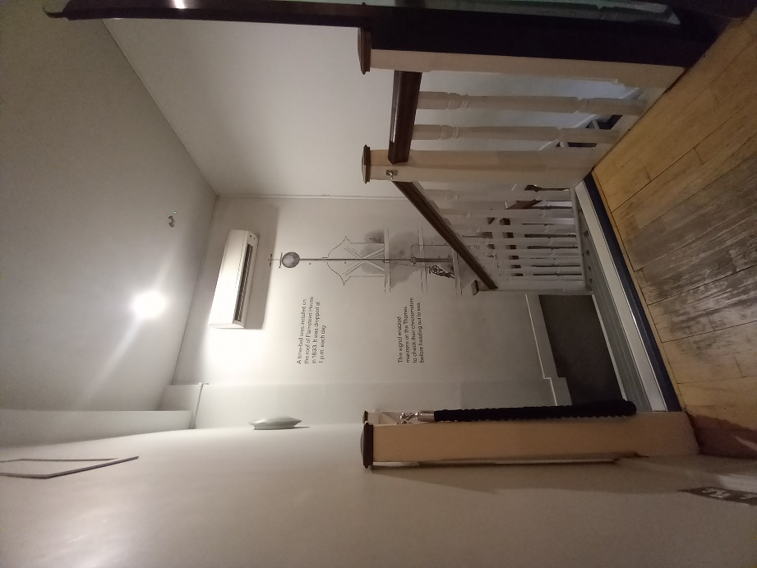
Image 9 Staircase to Time and Greenwich

The exit from Time and Greenwich is also the exit of Flamsteed House with stairs leading to the Astronomers Garden area. The staircase has 15 steps and requires a change in direction. There is also a lift available.
Picnic benches and tables are available in the Astronomers Garden.
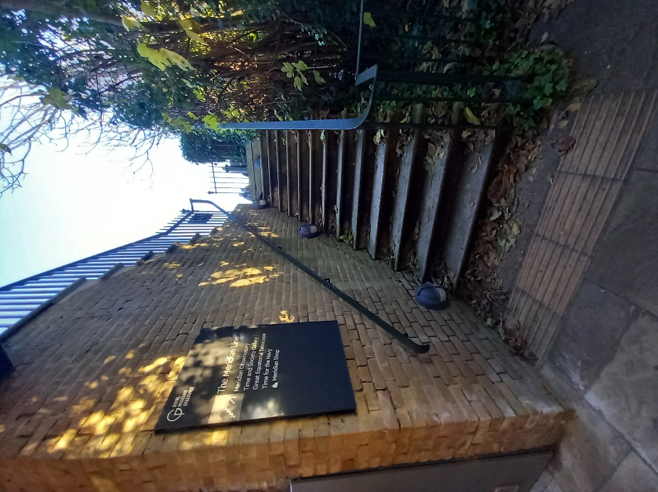
Image 10 Exit from Time and Greenwich

Lift
The access lift on the side of Flamsteed House offers level access to Time and Longitude Gallery and Time and Greenwich galleries. The Octagon Room is not accessible via the lift.
The lift doors are 100cm wide. Inside the lift is 100cm wide and 139cm deep.
Access to the lift is available from the Astronomers Gardens immediately after admission.
Take the lift to the upper floor for entrance to Flamsteed House and the Longitude Gallery. A bell is available under the Flamsteed house sign, and a member of staff will let you in momentarily.
Take the lift to the lower level to gain access to time and Greenwich.

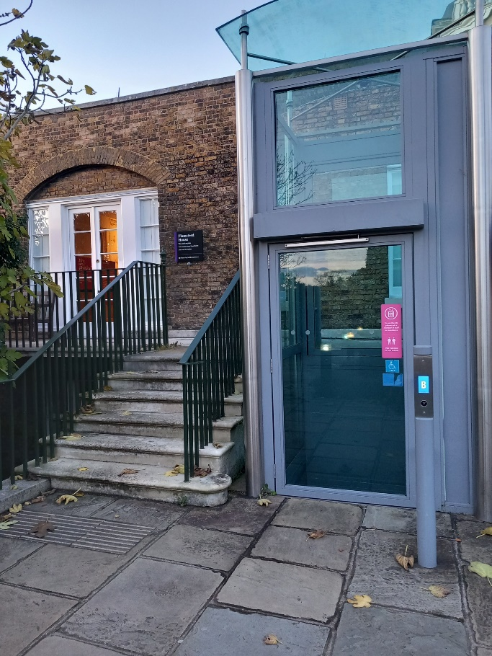
Image 11 Lift Ground Floor

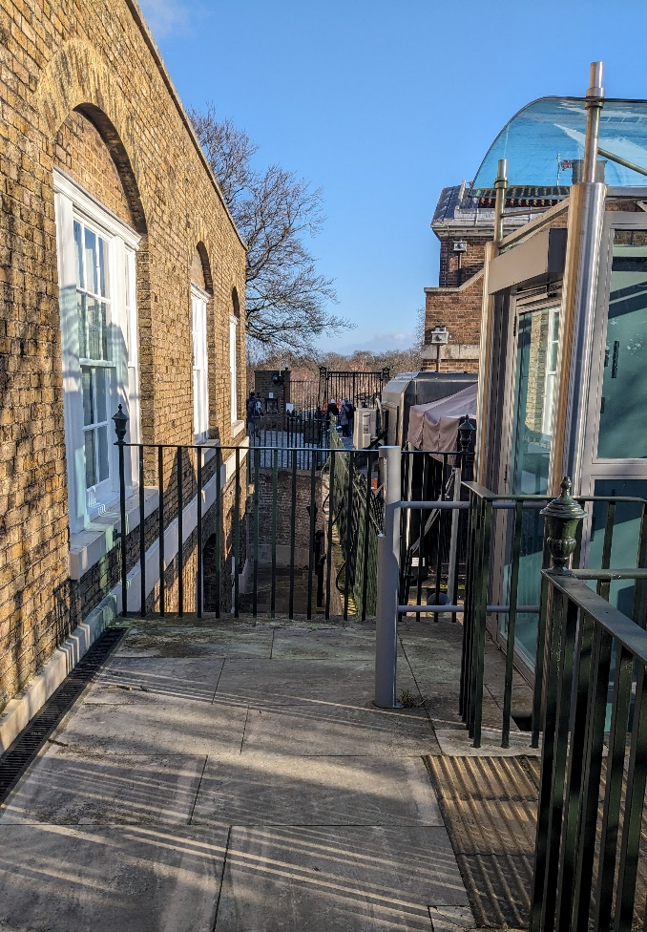
Image 12 Lift exit for Flamsteed house and Longitude Gallery
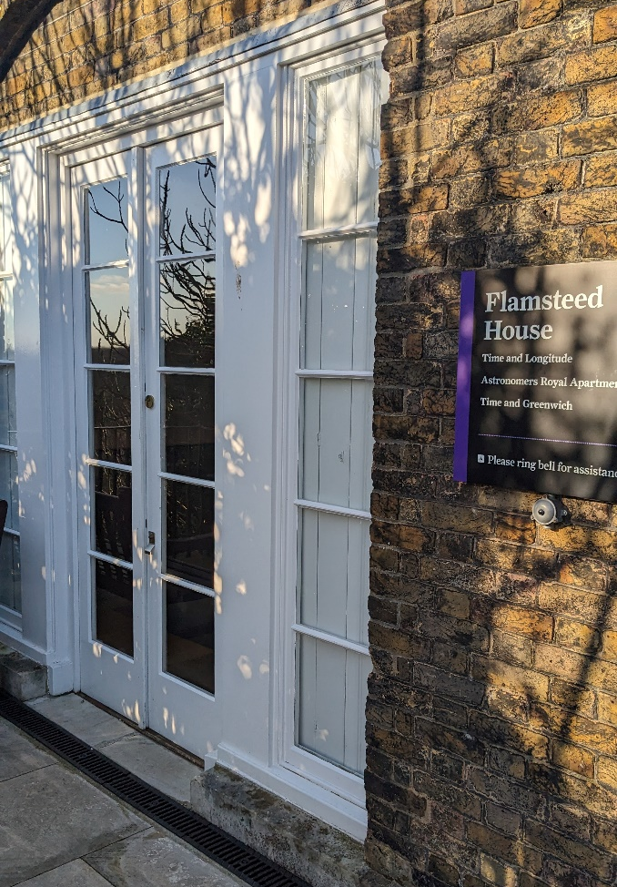
Image 13 Entrance to Flamsteed house and Longitude Gallery. Ring bell under Flamsteed house sign for entry.

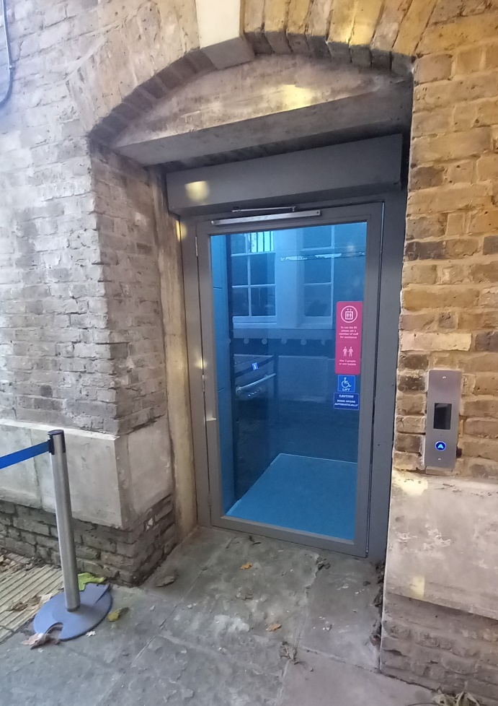
Image 14 Lift Time and Greenwich level (lower floor)

Camera Obscura
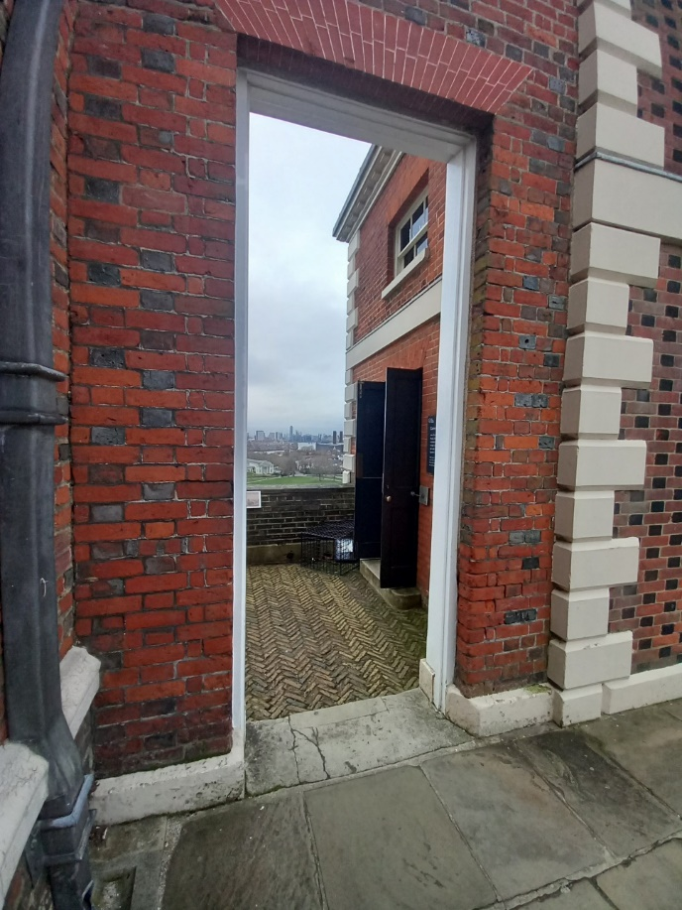
Image 15 Balcony and Camer Obscura
There is a small step of 8cm down to the Balcony area and a step up of 18cm into the Camera Obscura. The light levels inside are very low to enable to see the image.

Meridian Observatory, Meridian Shop and Great Equatorial Telescope Dome
Leading from the courtyard is a path with a ramp and stairs to the Meridian Observatory Entrance. The entrance is 104cm wide.
The floor in Meridian gallery is wooden floor.
There is lots of natural lighting in the Meridian Observatory, except for Time and Society gallery which has more sensitive items on display.
The width of the doorways varies in the Meridian Gallery between 80 and 121cm.

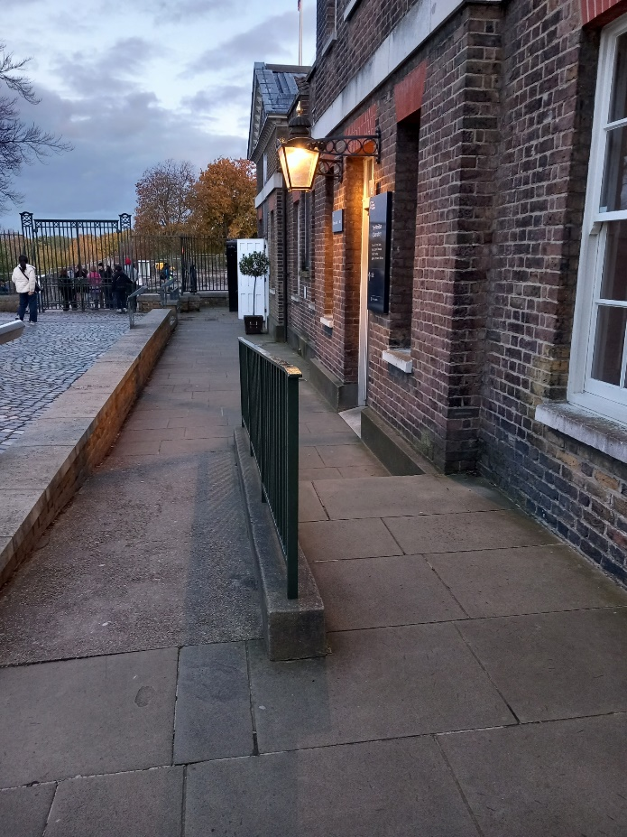
Image 16 Steps and Ramp
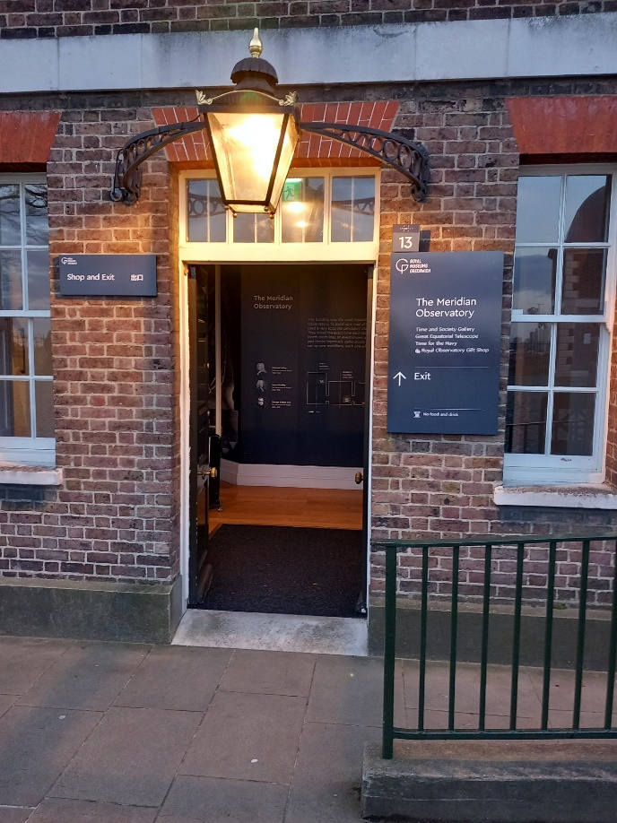
Image 17 Meridian Observatory entrance

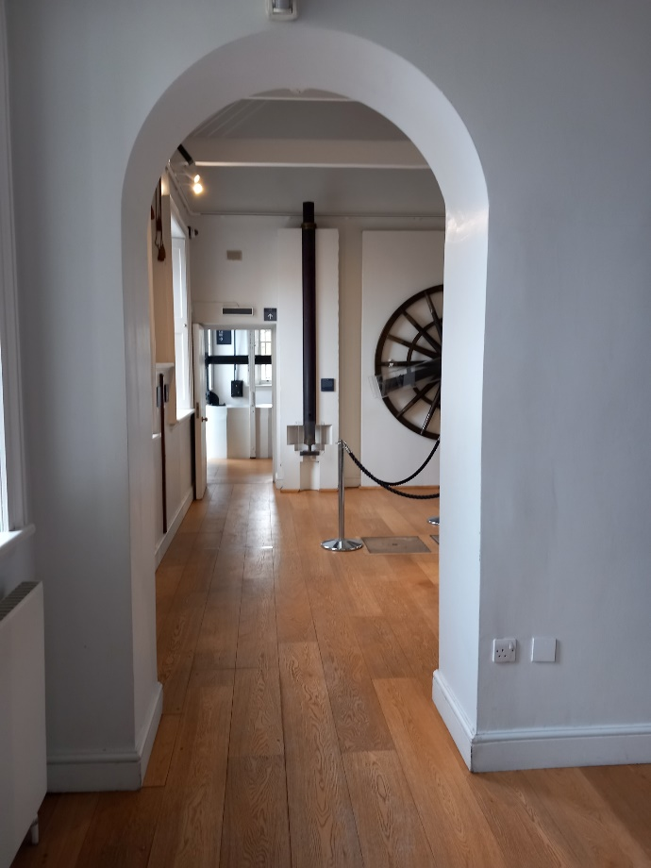
Image 19 Meridian Observatory
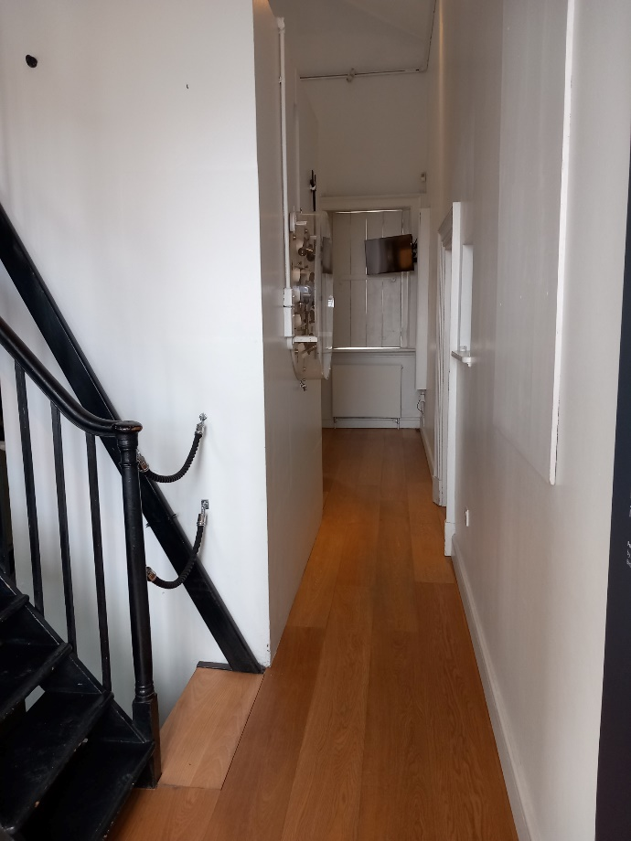
Image 18 Airy's Transit room
Exit via Meridian Shop. The glass door is often popped open and 90cm wide.
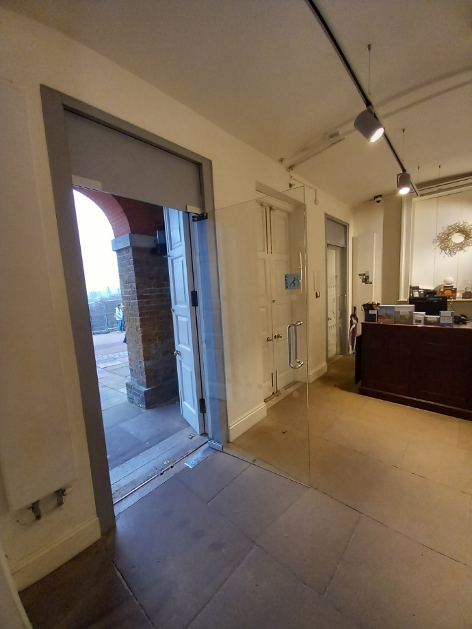
Image 20 Meridian Shop exit

The floor in the Meridian Shop is stone tiles. The stairs to the Time and Society gallery are 113cm wide and contain of two flights with 19 stairs.
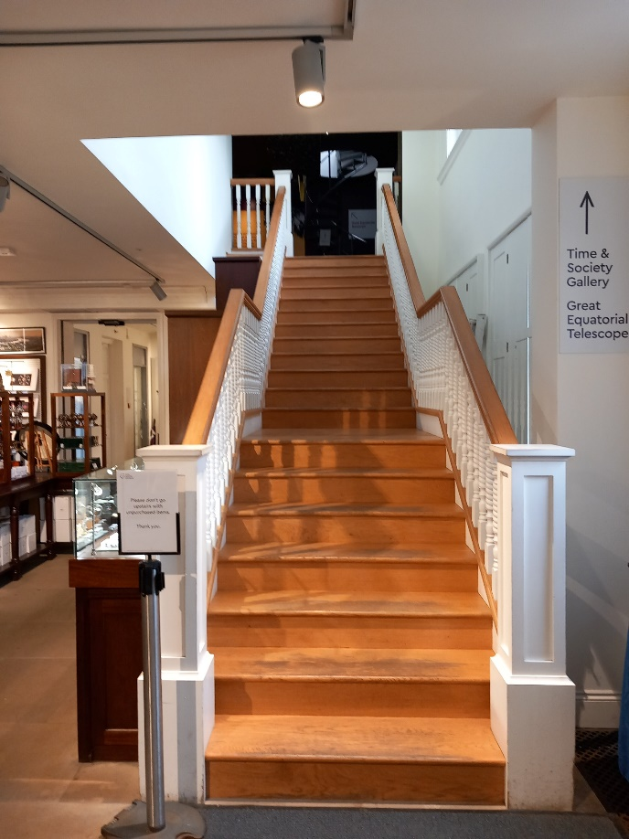
Image 21 Stairs to Time and Society gallery

The spiral stairs to the Great Equatorial Telescope dome are covered with rubber mats and there are 17 steps to the top. The floor in the Great Equatorial Telescope is tiles.

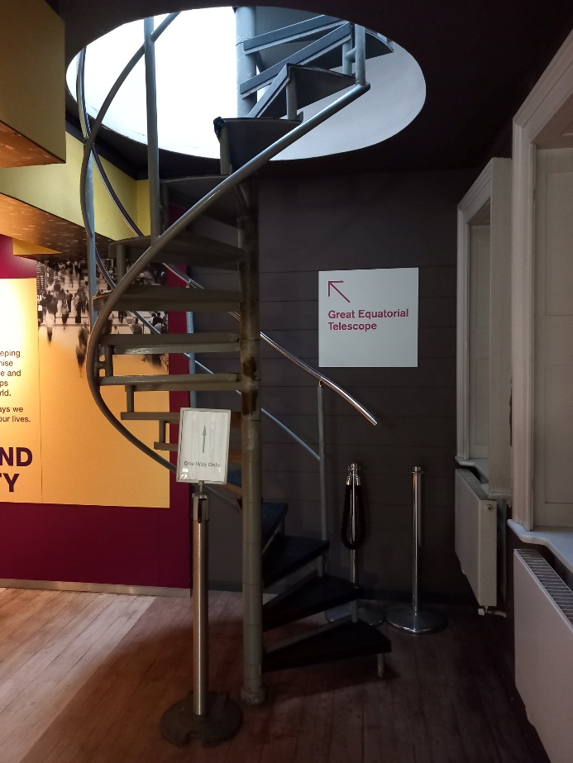
Image 22 Spiral stairs to Great Equatorial Telescope dome

On top of the spiral staircase there are two doors leading out to the GET balcony. The width of the doors varies between 60 and 63 cm.
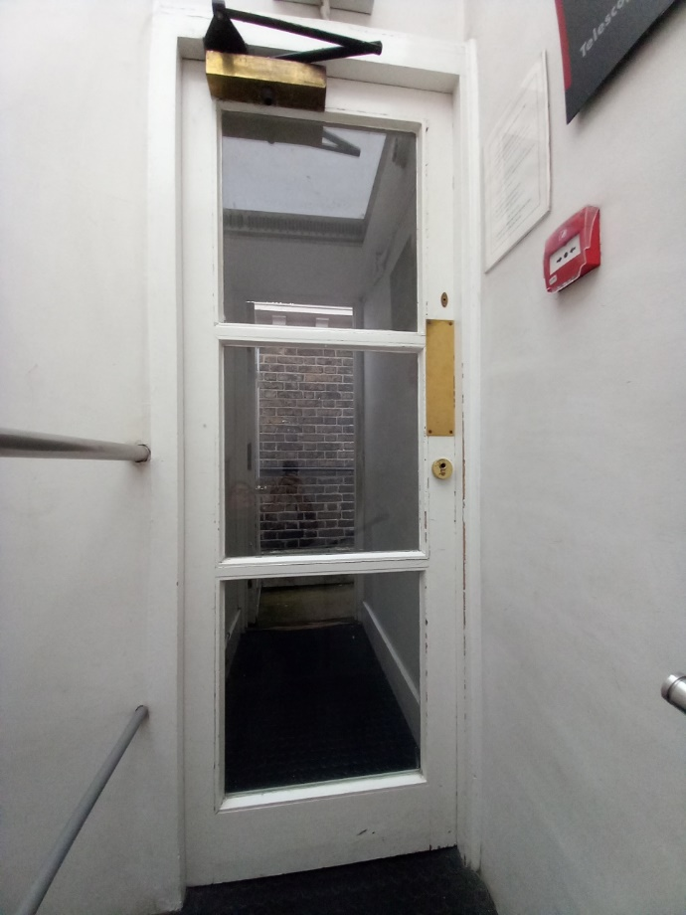
Image 23 Inner door to GET balcony

There are two steps along the balcony leading around to the entrance door to the Telescope Dome. The door is 55 cm wide, but a second door can be opened to offer a wider opening.
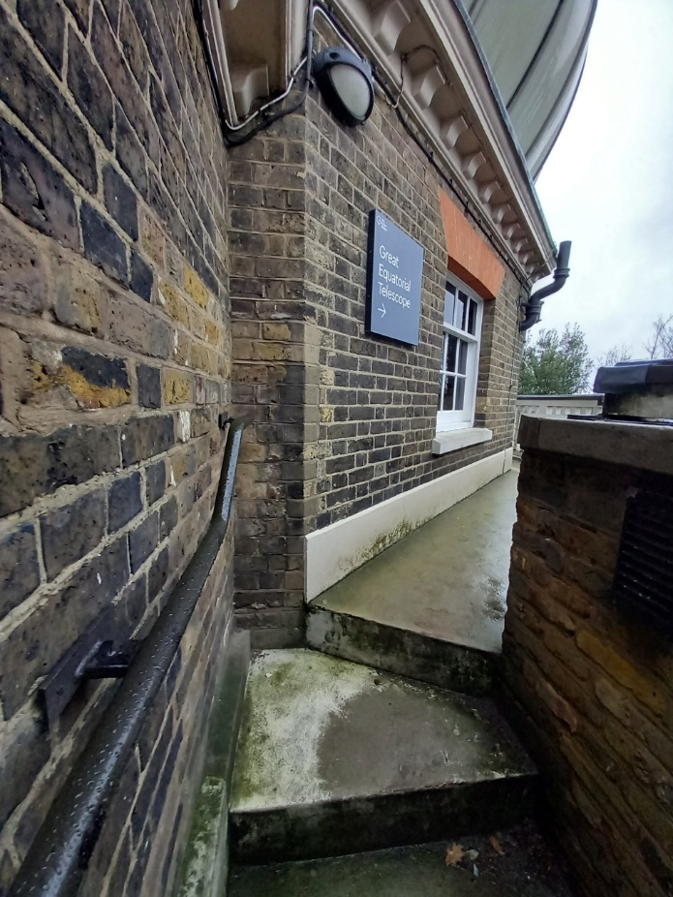
Image 24 GET balcony

The iron staircase exiting from the Great Equatorial Telescope has a pattern with small holes. There are 2 flights of stairs with a total of 37 steps leading down to the exit. The stairs are wedge shape to create the spiral with their thinnest point are 4.5 cm and largest 36 cm.
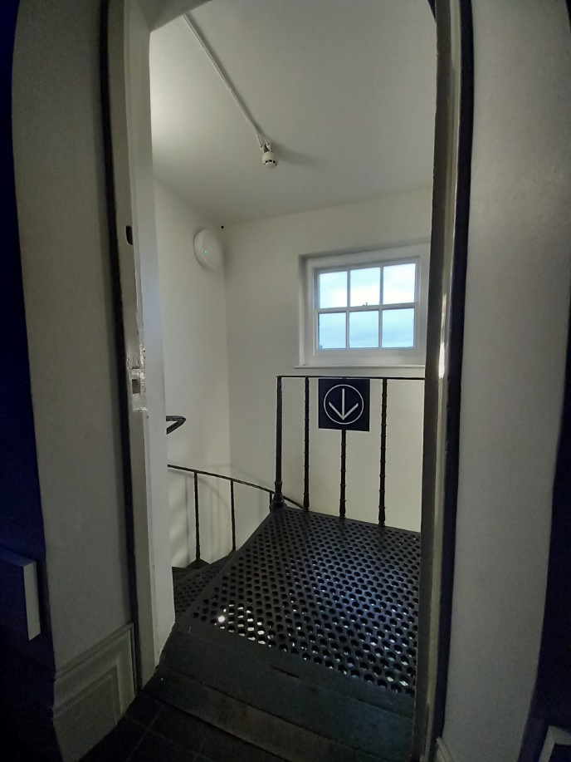
Image 25 Iron staircase exiting from GET

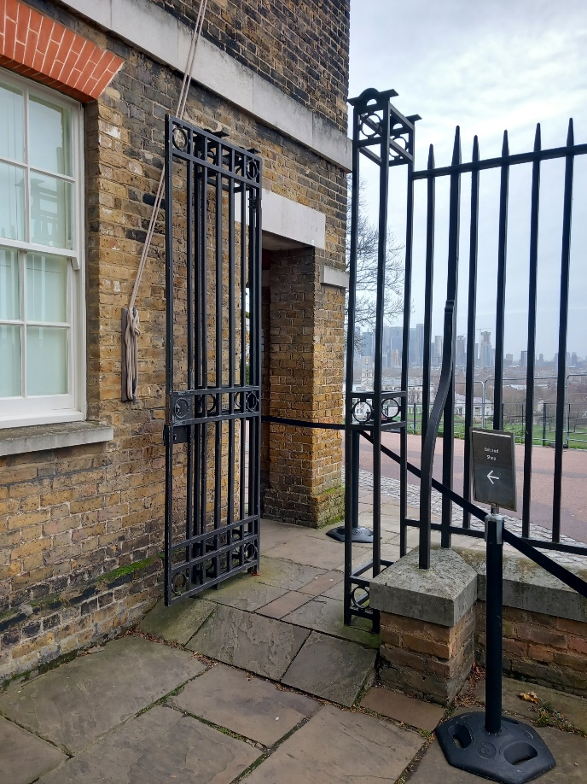
Image 26 Exit gate with small ramp
There is a small steep ramp (14 cm in height) exciting through the gate which is 84cm wide.

Toilets
There is an accessible toilet located in the Astronomers Garden. On the right when exciting the ticketing office.
In case of emergency of if assistance is required there is a red cord to be pulled which hangs by the toilet.
The door is 79cm wide, the toilet seat 47cm heigh and the sink 80cm.
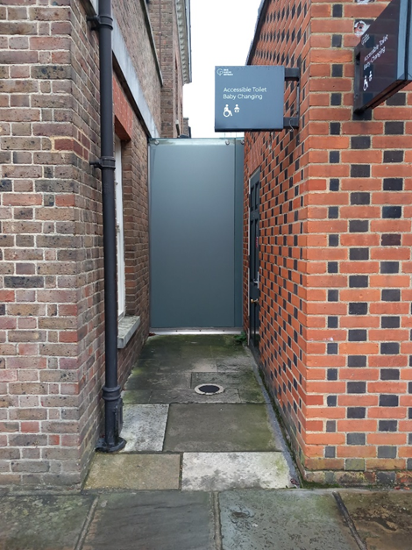
Image 27 accessible toilet and baby changing

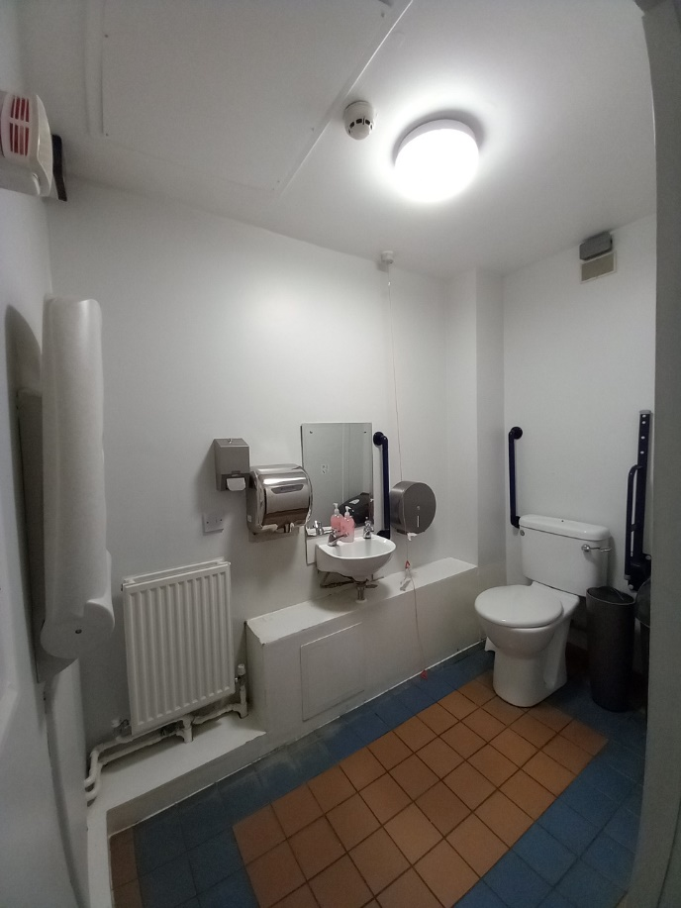
Image 28 Inside accessible toilet
Other toilets are located underneath the courtyard. There are two set of stone stairs leading down with 13 steps each. A further 4 steps lead down to the entrance of the female and male toilets.
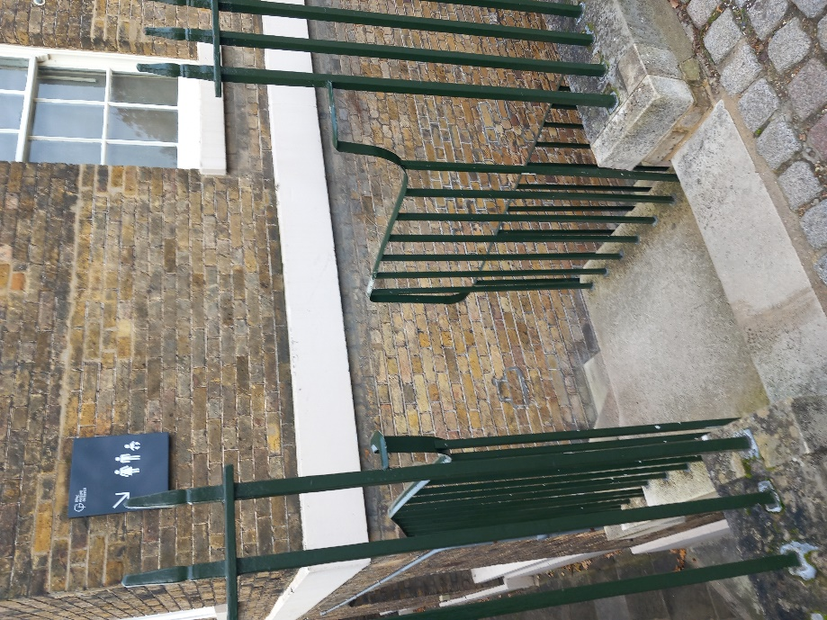
Image 29 Stairs to toilets
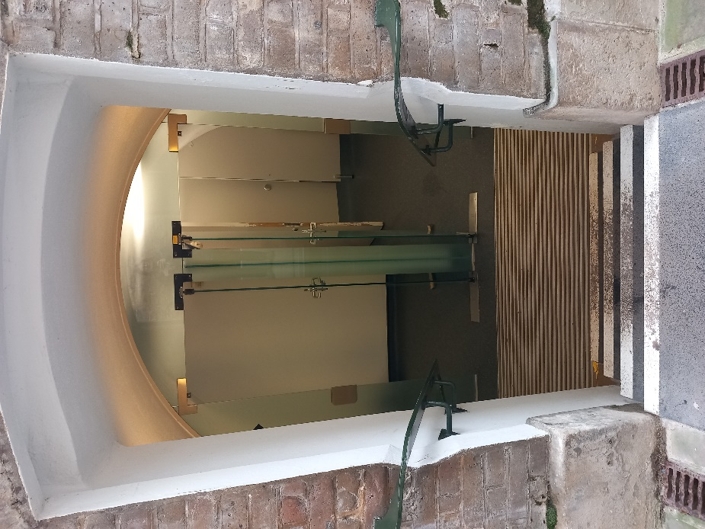
Image 30 Entrance to toilets
There are 3 cubicles and 4 urinals in the male toilet and 5 cubicles in the female toilets. Baby changing facilities are also available in both areas.

Altazimuth Building
The Altazimuth Building is not part of the general offer and might not always be open to the public. The south entrance has a small ramp leading up to the entrance door which is 82cm wide.
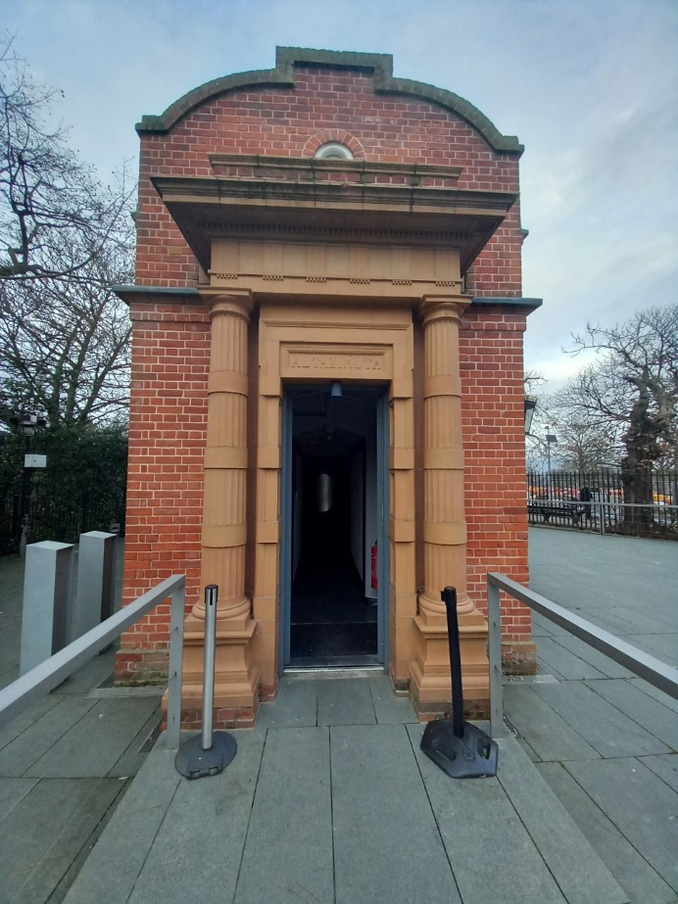
Image 40 Altazimuth Building
Additional information
Please let us know if you have any suggestions for the access statement or our facilities by emailing enquiries@rmg.co.uk, you can also speak to a member of staff when you are on site.
Contact information.
Address: The Royal Observatory, Royal Museums Greenwich, London SE10 9NF
Bookings: bookings@rmg.co.uk
Enquiries: enquires@rmg.co.uk
General enquiries: 0208 858 4422

